**Drone description**

**A picture of the drone**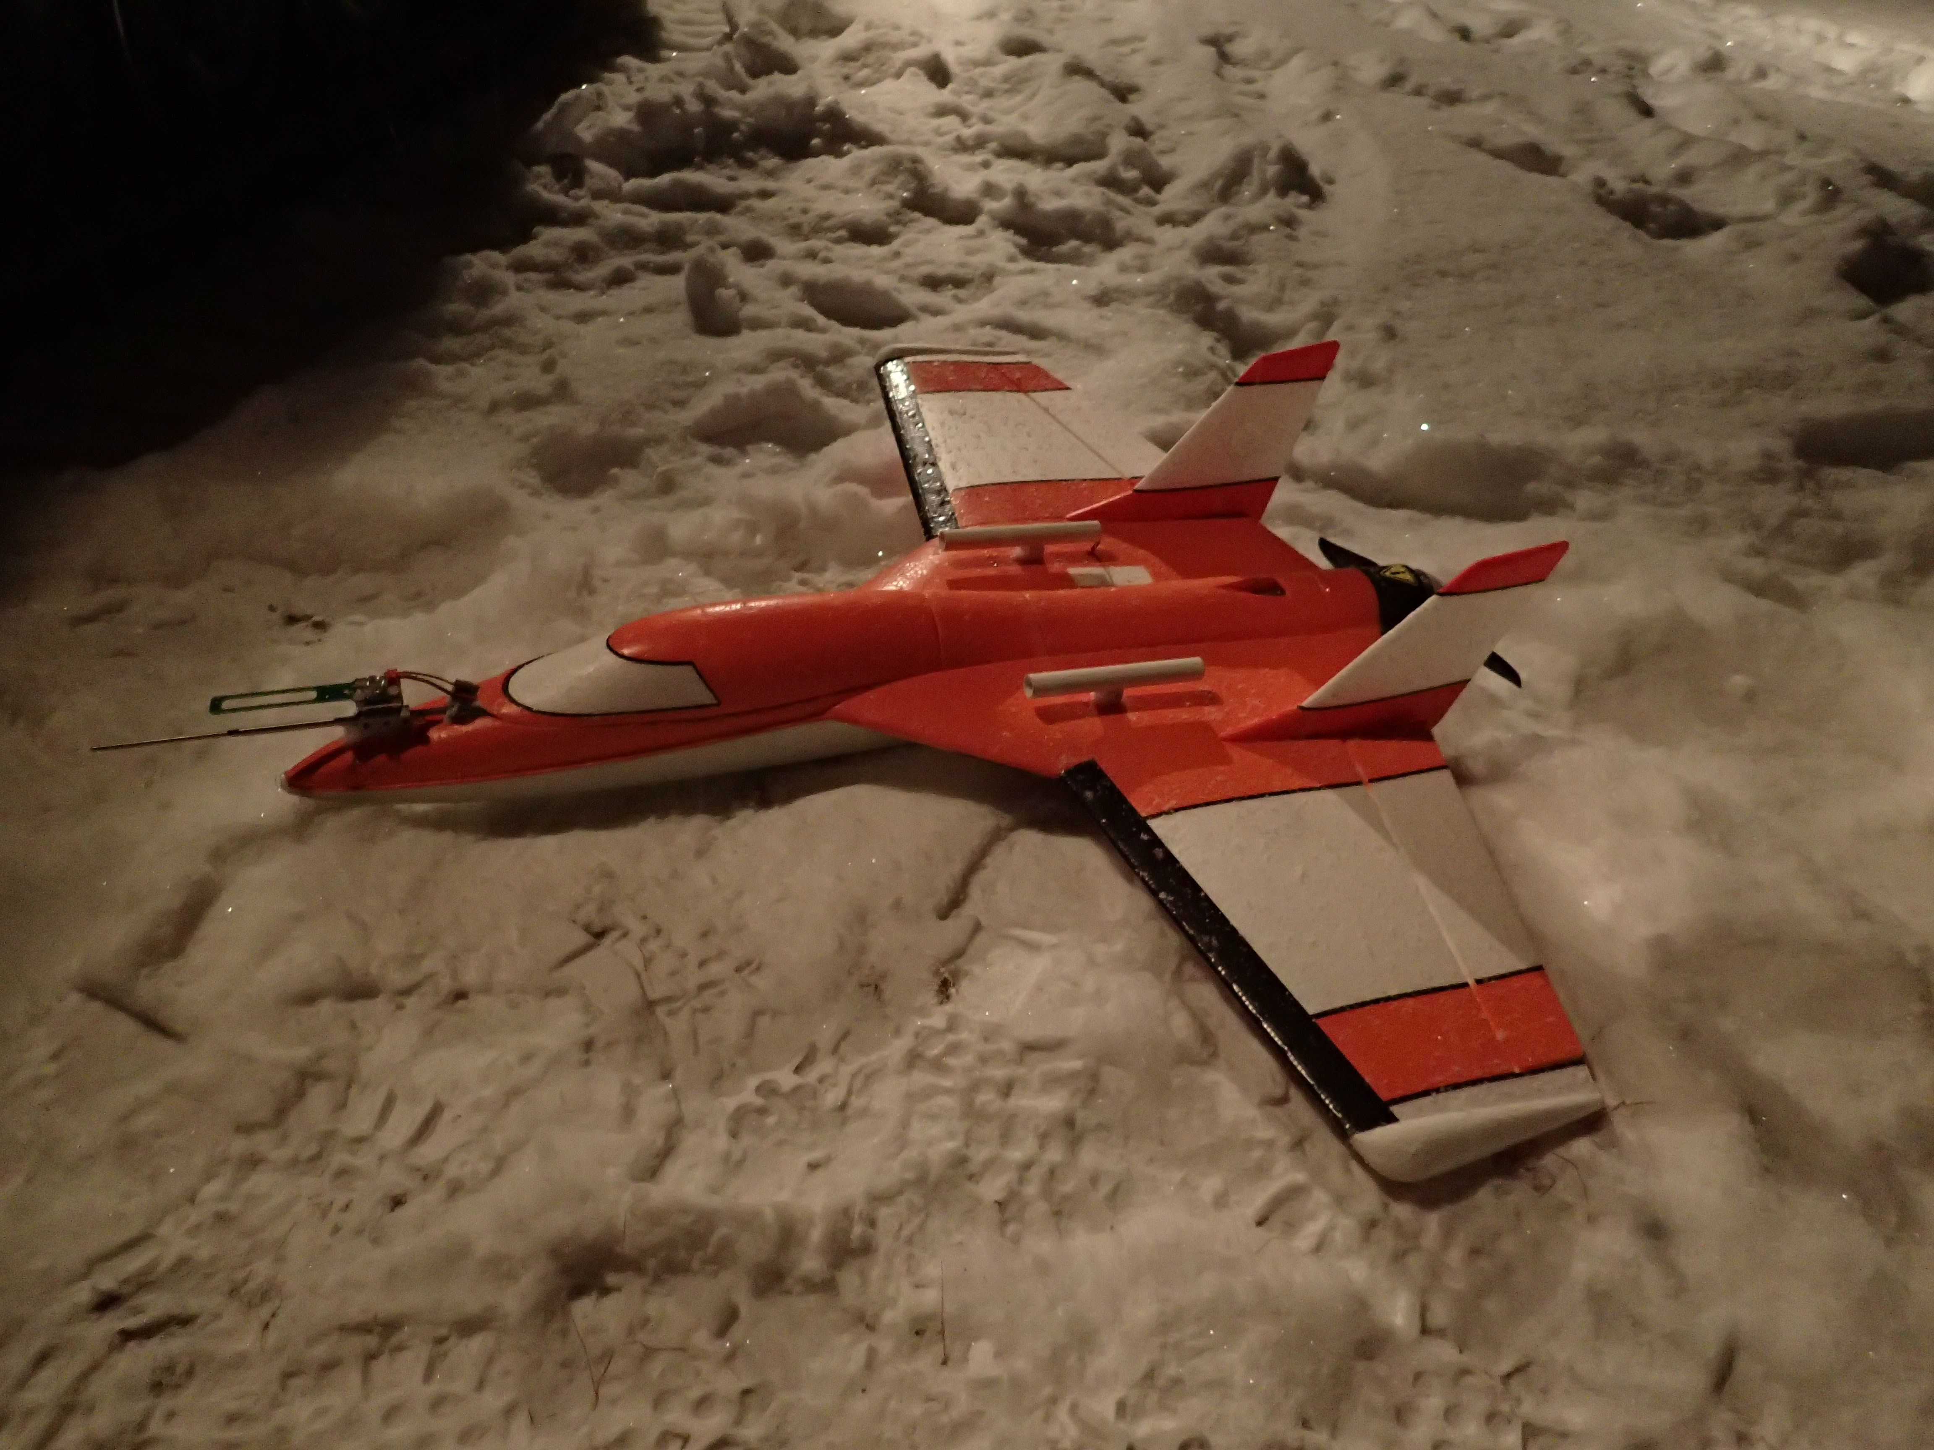

**A picture of the ground station**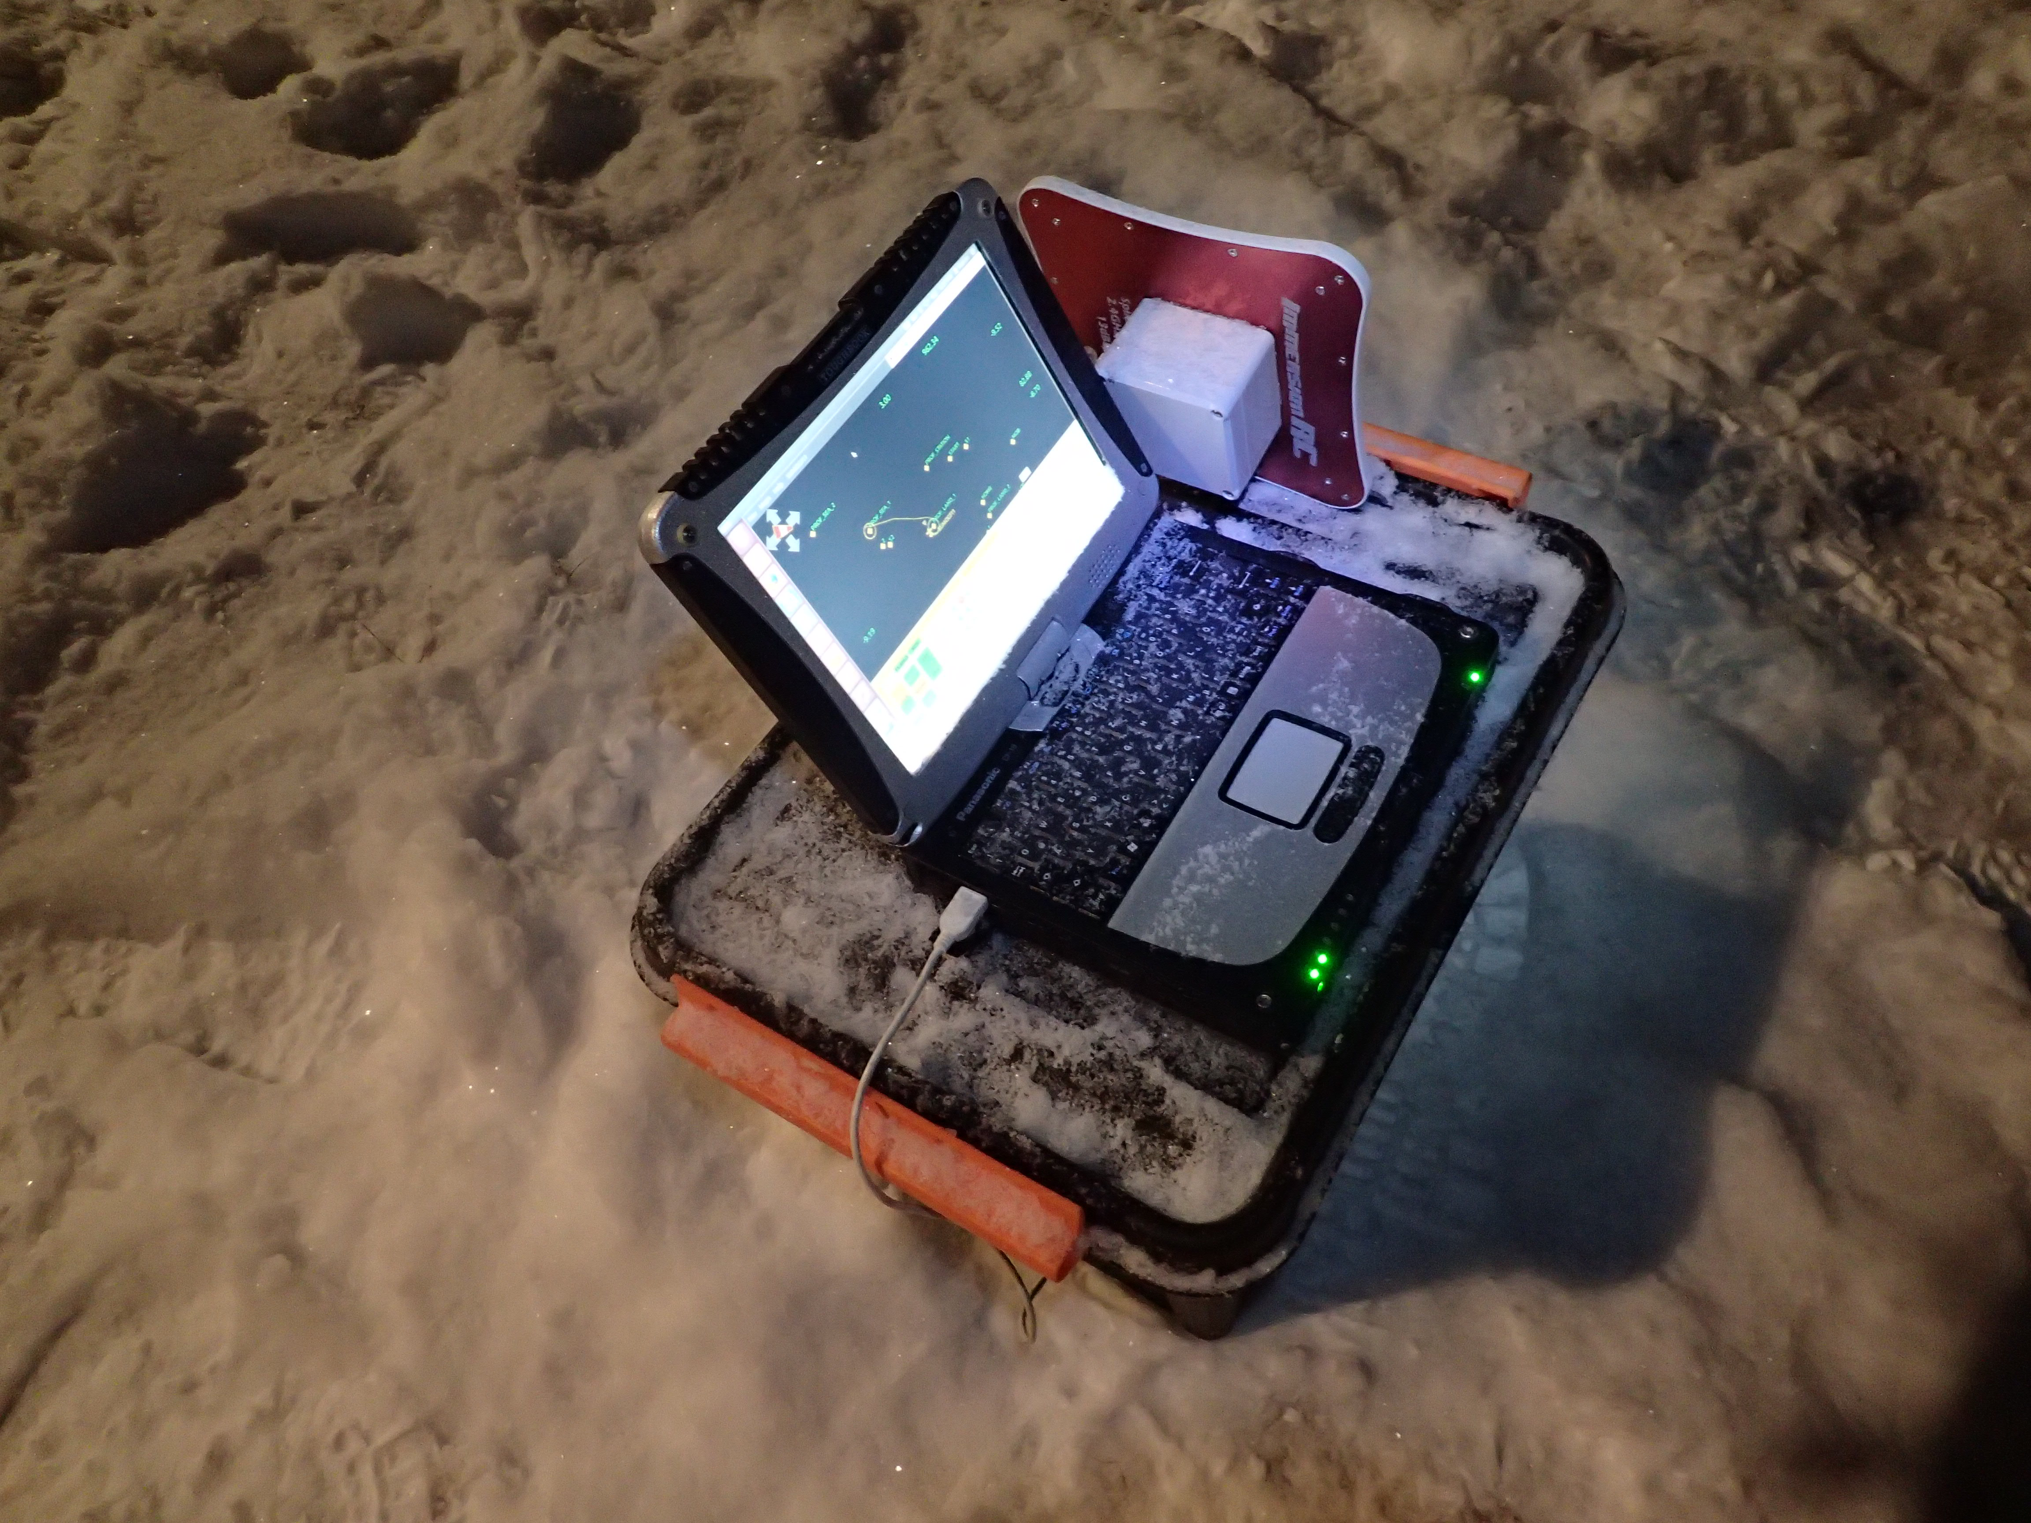

**System general information:**

The SUMO RPAS is based on a commercially available model construction kit (Fanjet by Multiplex) made from Expanded Polypropylene (EPP) and with a length and wingspan of 80 cm. It has been reinforced by glass fibre coating at the bottom of the fuselage, the front part of the wing and the base for the motor at the rear part of the fuselage. There is only very little dense material exposed to the outside so that even in the case of a crash the impact force and energy will be limited. The propeller and motor are installed in a pusher configuration at the rear end of the aircraft. With its overall take-off weight of about 650 g, the system is comparable to the mass of the routinely used weather balloon (radiosonde), and less than a duck.

The top of the entire fuselage can be removed to allow easy access the battery and avionics, GPS, antennas and autopilot electronics inside. The meteorological sensors are partially mounted on top of the nose and the wings, inside the wings and inside the fuselage. The SUMO has one electric motor located in the rear.

The SUMO is equipped with the open source autopilot system Paparazzi, mainly developed and maintained by the École Nationale de l’Aviation Civile (ENAC), Toulouse. The Paparazzi autopilot uses an inertial measurement unit (IMU) to sense the aircraft’s attitude. An integrated GPS receiver measures the position, heading and climb rate. Standard PID controllers are used for horizontal and vertical stabilization through the two control surfaces (elevons). The throttle is set through a combined control loop that keeps a minimum speed over ground by having a minimum throttle setting and pitch setting.

The system has three different control modes. Mode 1 is full manual and in this mode the aircraft can be flown like a normal RC aircraft. Mode 2 (AUTO 1) is the stabilized mode in which the aircraft’s pitch, roll and altitude are limited by the on-board IMU. In Mode 3 (AUTO 2) the autopilot controls the aircraft.

The Paparazzi autopilot is used by more than 50 registered educational and scientific users all over the world. The SUMO system has been operated in numerous field campaigns in different parts of the world. About 1000 scientific flights have proven the reliability of this system even under harshest conditions

**Characteristics**

A general description of the characteristics of the drone.

The design of the SUMO allows for high climb speeds and the relatively good gliding capabilities allow for controlled landings even without throttle. The insulating characteristics of the airframe contribute to a good performance under very cold conditions. During flight the nose and tail of the SUMO are indicated by white LEDs (flashing in the back), right and left wing by red and green LEDs, respectively.

**Risk analysis**

A risk analysis of the technical part of the drone.

The technical solutions and the control electronics on the SUMO are among the best available on the hobby market ensuring high quality and great reliability. The autopilot system in use is Paparazzi, an open source hardware and software autopilot system, developed and maintained under the lead of the École Nationale de l’Aviation Civile, Toulouse, France. It is used by numerous research groups all over the world and has proven its reliability and robustness under most extreme conditions.

However, one must pay extra attention to it when it comes to safety. There are few redundancy systems and one must assume that a failure can be catastrophic. It is important to consider this when planning the flight and safety zones.

Strong winds may cause negative ground speed, which will lead to a loss of the GPS-based aircraft-heading estimation. This problem is prevented by flying with a higher throttle setting and an increased negative pitch. The GCS operator has to make sure that the aircraft is set accordingly if strong winds are experienced. Furthermore, all operations in atmospheric profiling should as far as possible take place with the aircraft to the windward side of the start point to provide an additional safety margin for strong wind speeds during ascent. To ensure that the aircraft can be returned to its start/landing point a flight level with lower wind speeds shall be chosen through either the RPC or manually by the safety pilot.

Moreover, the SUMO system includes a number of important automatic safety functions, which make the system reasonably fault-tolerant and ensure safe and predictable behaviour also in “degraded” conditions:

* Manual/automatic control: The safety pilot can overrule the on-board autopilot and the remote pilot station at any time during automatic operation (when the RPAS is within RC range) by switching the aircraft into manual “radio-control” mode. In this mode the pilot can either fly the aircraft manually or terminate the flight by shutting down the motor and letting the aircraft enter a tailspin. This will bring down the aircraft slowly, drifting with the wind, and with very limited kinetic energy.
* A fly-away prevention system (geo-fencing): If the aircraft for some reason leaves a predefined area (usually a circle with radius 300 m around the start point) or exceeds a predefined maximum altitude (400 ft. for VLOS), the on-board computer will terminate the current mission and guide the aircraft to a predefined holding pattern (typically a circle at 350 ft. altitude) close to its start position, from where it can be manually recovered by the RPAS pilot. If the aircraft fails to return to the start position, and leaves the specified operation area, the on-board computer will eventually shut down the motor to terminate the flight.
* Energy management: In case the aircraft battery voltage drops below a predefined value, corresponding to ca. 10 min of remaining operation, the RPAS will return to its start position and enter a holding pattern at 350 ft. AGL, until it is landed manually by the safety pilot. In the event of motor failure, the autopilot will guide the aircraft down to the holding pattern in gliding mode.
* Loss of data-link procedure: The data link of the 2.4 GHz modem is usually ensured in a cylinder of 1000 m in diameter and 10000 ft. AGL. For BVLOS flights special patch antennas are used which extend the range of the data link significantly. In case of complete loss of the communication link (2.4 GHz modem) between the RPAS and the GCS for more than a user predefined time interval (usually 30 s), the RPAS will return to its start position and enter a circular holding pattern at 350 ft. AGL, until it is landed manually by the safety pilot.
* Loss of GPS position procedure: If the GPS signal is lost and the autopilot does not get position information, the autopilot will use the IMU (attitude sensor) to enter a controlled circular flight pattern and descend at slow speed until it hits the ground with minimum kinetic energy.
* Loss of attitude procedure: If the IMU (attitude sensor) gets degraded and the autopilot cannot control its flight, the autopilot will switch off the motor and the aircraft will enter a tailspin.

To reduce the risk of GPS loss the SUMO should never be started without receiving signals from a sufficient number of satellites (typically 6) and the normal procedures have to be followed.

**Components**

A description of what kind of hardware the drone is built up by.

The SUMO consists of the Funjet, Multiplex airframe, Axi 2212/26 Gold Line motor, Jeti motor controller and Graupner DES-476 BB digital servos. The autopilot controller is Umarim Lite v2 with integrated IMU and NEO-6M GPS Module. The modem is 2.4GHz XBee pro and the RC receiver a Futaba FASST R617FS.

**Ground station:**

The SUMO GCS is based on a Panasonic Toughbook laptop computer running the Paparazzi GCS software on a Linux distribution. The Paparazzi software supports a range of radio modems and it also contains the possibility of simulating flight missions. The GCS software provides the operator with possibilities to alter the aircraft’s flight plan, target altitude and speed in-flight, in addition to modify control gains for tuning the flight characteristics. Relevant parameters such as battery status, ground speed and climb speed in addition to weather data, like wind speed, wind direction and temperature, are displayed in real time on the GCS screen. These parameters should be continuously monitored by the GCS operator to ensure safe flight and to keep operation within the given weather limitations.

In addition to this the Paparazzi software also provides an option for simulating flight plans under different wind conditions. Prior to any flight using a new flight plan, the flight plan should be simulated using the Paparazzi simulation software applying realistic wind conditions to ensure a proper and safe design and to thereby minimize the risk of mishaps during flight related to a poor flight plan design. The software can also replay flown flight missions and this feature may be especially useful in the event of mishaps.

**Technical Specification**

Vehicle mass: 580g  
Take-off weight (max): 750g  
Payload mass (recommended): 120g  
Payload mass (max): 170g  
Battery: 11.1 V (3S), 4.0 Ah

Climb rate: 8 m/s  
Cruise speed: 15 m/s  
Endurance: 45 min  
Flight radius: 20 km (horizontal range)

**Operational Conditions**

Temperature range: -30degC 40degC  
Humidity: 0-95% (flying in clouds under freezing temperatures is not recommended, precipitation should be avoided)  
Wind tolerance: 18 m/s (avoid flights when the wind speed close to ground is around 15 m/s)  
Minimum visibility: 150 m

**Physical dimensions and colour**

Diameter (multirotor)  
Height: 15 cm  
Length (fixed wing): 75 cm  
Width (fixed wing): 80 cm  
Colour: Orange-white

**Payload**

Meteorological sensors, for T, RH, p, long-wave radiation, optional five-hole probe and fine wire temperature sensor.

**Normal procedures**

Checklist of normal procedures:

* Pre-Flight Checks: Campaign and Mission Planning
  + Required permissions in place
  + NOTAM for UAS operation issued (if applicable)
  + Temporarily restricted area (TRA) activated (if applicable)
  + Maps for the GCS downloaded
  + Terrain height for the GCS downloaded
  + Important POIs defined
  + Points for automatic landing defined
  + Safety zones defined
  + Fail-safe modes defined
* Pre-Flight Check List: RC
  + Battery charged
  + Antenna properly mounted
  + Throttle in ZERO POSITION
  + Mode switch in MANUAL
  + Correct pre-programmed aircraft definition active
* Pre-Flight Check List: GCS
  + Battery charged
  + Correct telemetry antenna connected to the GCS
  + Correct flight plan selected
  + Correct flight mode selected
  + Correct aircraft selected
  + Paparazzi GCS application running
* Pre-Flight Check List: SUMO airframe
  + Battery charged
  + Fuselage intact
  + Wings intact
  + Tailerons intact
  + Servo mountings intact and tightly connected
  + Propeller mounting intact
  + Propeller intact
  + Motor mount intact
  + Cover for electronic compartment closed and safely secured
  + Battery mounted and fixed in proper position
  + Centre of gravity properly placed
  + Sensor mounting ok and sensors properly aligned
  + Sensors clean
  + Pitot tube/5-hole probe properly tubed
  + Payload cover safely closed
  + Correct flight plan uploaded
* Check List: SUMO start procedure
  + Safety transmitter ON
  + GCS switched on and Paparazzi application running
  + Battery connected
  + SUMO after battery connection motionless and levelled for IMU setup
  + Elevator stick back -> tailerons move up
  + Elevator Stick forward -> Do tailerons move down
  + Aileron stick right -> Does left taileron move down and right up
  + Aileron stick left -> Does left taileron move up and right down
  + Fuselage closed and secured
  + Throttle forward, while aircraft is held tight and propeller can turn freely -> Does motor turn at full speed giving trust in the right direction
  + Hold SUMO levelled -> Is horizon horizontal and vertically aligned
  + Rotate SUMO right -> Does horizon tilt to the left
  + Rotate SUMO left -> Does horizon tilt to the right
  + Point SUMO nose downward -> Does horizon move up
  + Hold SUMO levelled and point nose upward -> Does horizon move down
  + Is GPS 3D fix available and stable
  + Is the correct aircraft active
  + Is battery level ok
  + Is the correct map displayed
  + Is the SUMO position displayed correctly
  + Is telemetry data updated several times per second
  + Do a “Walk around”
  + Switch between all flight modes
  + Verify weather conditions
  + Verify start area is clear
  + Verify that wind is opposite to start direction
  + Start motors
  + Verify timer is running

**Emergency and safety procedures**

Emergency procedure checklist.

* The following general rules apply if an emergency situation appear:
  + FLY THE AIRCRAFT
  + ANALYSE THE SITUATION AND TAKE PROPER ACTION
  + NOTIFY PEOPLE IF NECESSARY WITH THE WORD: Danger!
  + LAND THE RPA AS SOON AS POSSIBLE IN A CONTROLLED MANNER
* Critical aircraft battery level during
  + Identify landing area
  + Set altitude to 100 m and wait until reached
  + Change flight mode to MANUAL
  + Pilot lands ASAP
* Telemetry link loss
  + Check that antenna cable is connected
  + If disconnected, reconnect and restart link-server
  + If directional antenna is used orient antenna towards aircraft
* RC link loss
  + RC power on
  + If RC link is not back initiate automatic landing